**ASSIGNMENTS ON DIGITAL MARKETING**

**NAME:** ARAVINDAVASAN.S

**DEPARTMENT:** BE.COMPUTER SCIENCE AND ENGINEERING

**COLLEGE:** 8151 DHANALAKSHMI SRINIVASAN INSTITUTE OF

TECHNOLOGY

**NAANMUDHALVAN COURSE**: DIGITAL MARKETING

**NM ID:** 21B0D14D377F54F985749BD7A86F7B08

**ASSIGNMENT 1:**

Create a blog or website using Blogspot and WordPress. Customize

The theme design and post new article with 500 words.

<https://a2scabs13.blogspot.com>

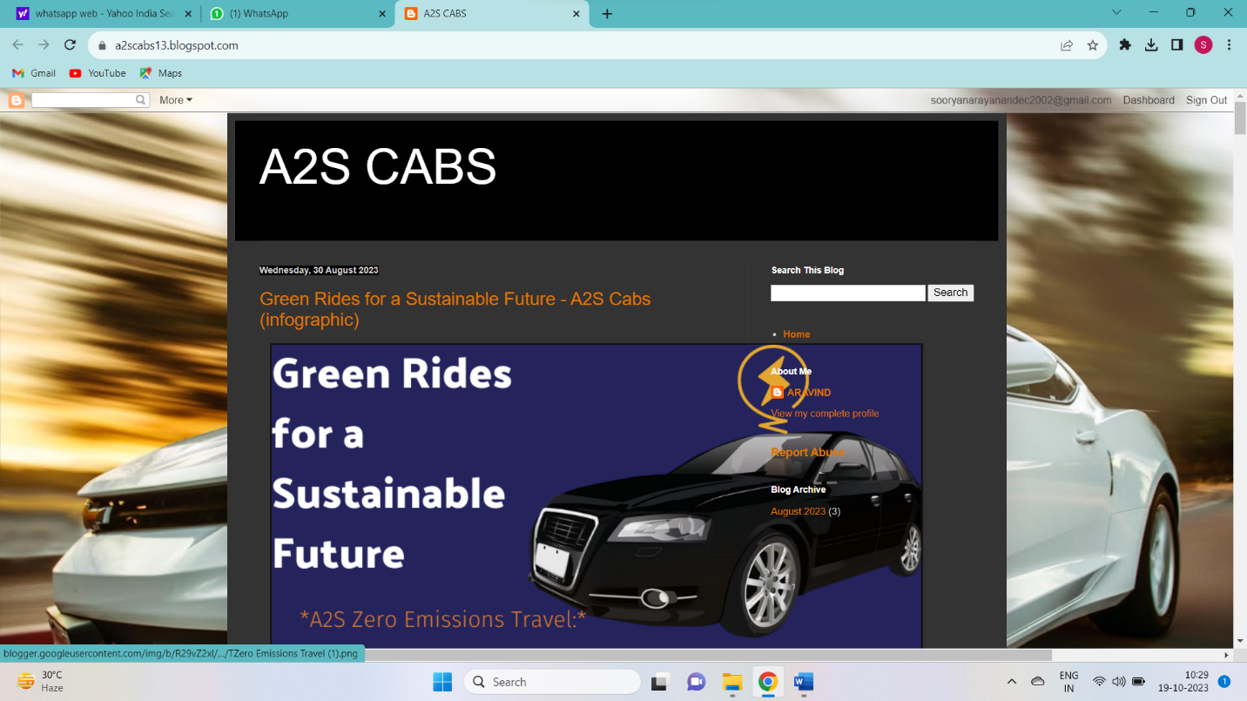

**ASSIGNMENT 2:**

Create a new Facebook business Page and Post one social media poster for your brand.

<https://www.facebook.com/AASCabs/>

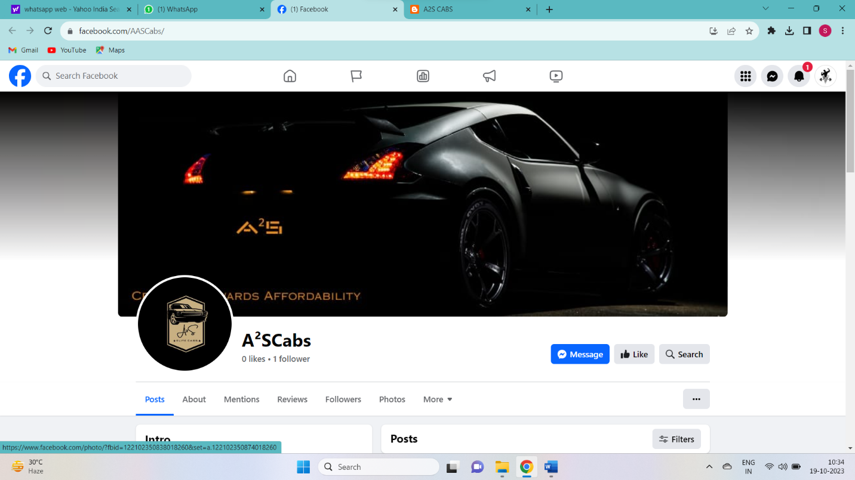

**ASSIGNMENT 3:**Create and design a social media advertisement poster using Canva



**ASSIGNMENT 4:**

4.Create email newsletter design using MailChimp or Canva tool.

<https://a2scabs13.blogspot.com/2023/08/email-news-letter-a2s-cab-service.html>

